You are invited to attend the

KWDC Phoenix Invitational

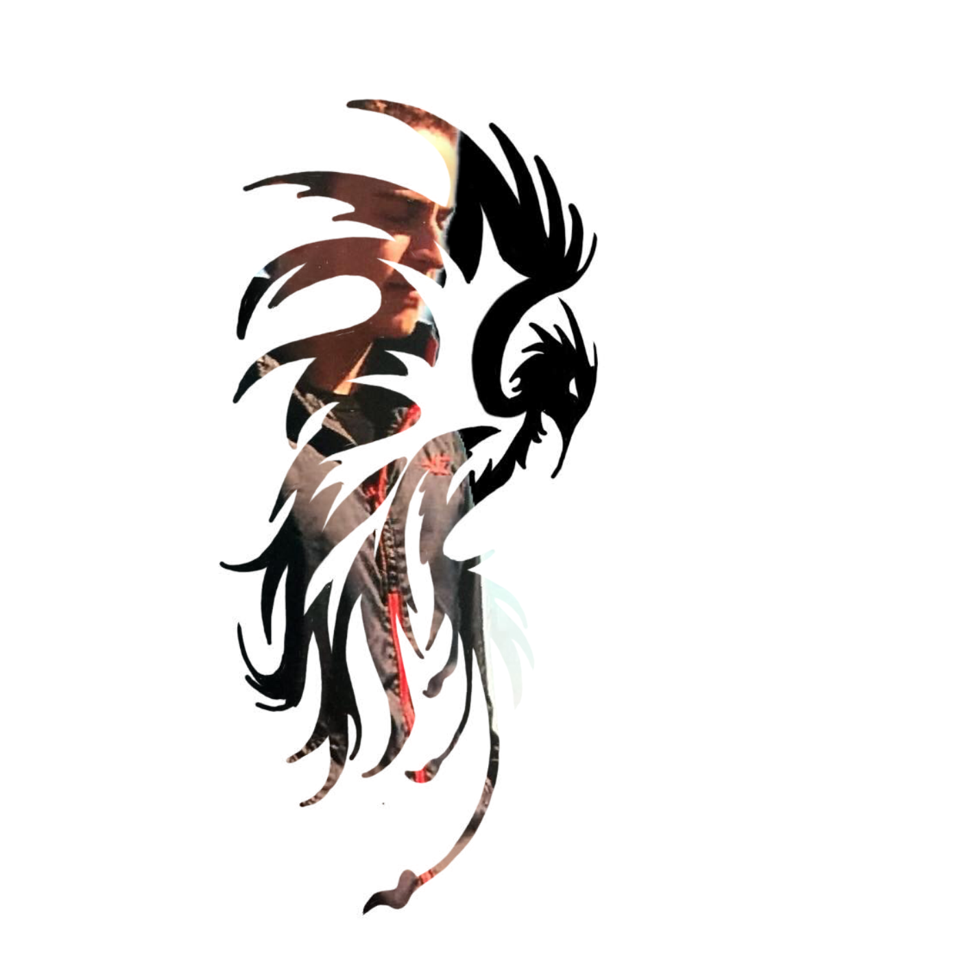

March 28th & 29th, 2020

Name of Event KWDC Phoenix Invitational
Date of Event March 28th-29th, 2020
Place of Event Brantford, Ontario (Wayne Gretzky Sports Complex)
254 North Park St. Brantford, Ontario N3R 4L1

Meet Manager: Name: Robyn Bate
Email: robyn_bate@hotmail.com

Technical Director: Name: Roland Lipki
Email: rolipki@gmail.com

Age Group: Determined by diver’s age as of December 31st, 2020

Eligibility: Open to all DPC registered divers.
Dive Ontario rules will apply
Please note Aspire I & Aspire II dive requirements (included)

Entry Fees: $50 per diver for registration fee ($10 to Dive Ontario)
$35 per event capped at 4 events ($10 to Dive Ontario)
Additional optional meal plan ($30 per athlete) can be added to the registration fee to cover
meals (breakfast and lunch) for both days

Entry Deadline: March 20th, 2020 by 11:59 pm
All registrations should be sent to kwdivingregister@gmail.com
A $25/diver late fee will apply to all late registrations.
etransfers should be sent to: eregisterkwdivingclub@gmail.com

Dive Sheets: Please submit dive sheets by March 22nd to robyn_bate@hotmail.com
Dive sheets received after that date are subject to late fees. Dive Sheets must be created using the latest version of the Coaches Dive Sheet Generator.
Please submit Aspire II divers as ‘Group “X” Tier II’ and Aspire I divers as ‘Group “X”’ (without any designation). (see Appendix A)

Facility: One 1m springboard
One 3m springboard
5m, 7.5m, 10m platform
* Please note there is no 3m platform

Awards: Medals: Gold, Silver, & Bronze
Ribbons: 4th, 5th, & 6th

Please complete the Meet Entry form below and forward to rolipki@gmail.com
KWDC Phoenix Invitational Meet Entry form

SCHEDULE OF EVENTS
(subject to change based on registrations)

Friday March 27th
Open Practice 5.30 to 7.30pm

Saturday March 28th
Coaches Meeting 8:30-8:45
Opening Ceremonies 8:45-8:50
Closed Practice 8:50-9:10

FLIGHT 1
One Metre |  | Three Metre
Event |  | Event
1  3  5  7  9 | Aspire II Girls E  Aspire II Girls D  Aspire II Girls C  Aspire II Girls B  Aspire II Girls A | 2  4  6  8  10 | Aspire II Boys E  Aspire II Boys D  Aspire II Boys C  Aspire II Boys B  Aspire II Boys A
FLIGHT 2
 |  | Platform (5 m)
 |  | Event
 |  | 11  12  13  14  15 | Aspire II Boys E  Aspire I&II Boys D  Aspire I&II Boys C  Aspire I&II Boys B  Aspire I&II Boys A
FLIGHT 3
One Metre |  | Three Metre
Event |  | Event
16  18  20  22 | Aspire I Boys D  Aspire I Boys C  Aspire I Boys B  Aspire I Boys A | 17  19  21  23 | Aspire I Girls D  Aspire I Girls C  Aspire I Girls B  Aspire I Girls A

Sunday, March 29th
Open Practice 7:30-8:30
Coaches Meeting 8:30-8:45
Closed Practice 8:50-9:10

FLIGHT 4
One Metre |  | Three Metre
Event |  | Event
24  26  28  30  32  34 | Aspire II Boys E  Aspire II Boys D  Aspire II Boys C  Aspire II Boys B  Aspire II Boys A  Masters - Men | 25  27  29  31  33  35 | Aspire II Girls E  Aspire II Girls D  Aspire II Girls C  Aspire II Girls B  Aspire II Girls A  Masters- Women
FLIGHT 5
 |  | Platform (5 m)
 |  | Event
 |  | 36  37  38  39  40  41 | Aspire II Girls E  Aspire I&II Girls D  Aspire I&II Girls C  Aspire I&II Girls B  Aspire I&II Girls A  Masters – Men and Women
FLIGHT 6
One Metre |  | Three Metre
Event |  | Event
42  44  46  48  50 | Aspire I Girls D  Aspire I Girls C  Aspire I Girls B  Aspire I Girls A  Masters - Women | 43  45  47  49  51 | Aspire I Boys D  Aspire I Boys C  Aspire I Boys B  Aspire I Boys A  Masters –Men

One metre and three metre events will run simultaneously
Events will be combined depending on the number of registrants
Each event will have a 20 minute closed practice
Award Ceremony will follow each event
Masters Events will only run if there are at least 3 participants – dive requirements listed below

PLEASE NOTE – THIS SCHEDULE IS SUBJECT TO CHANGE BASED ON REGISTRATIONS. We will change the events to consider the most optimal practice and board time for the divers.
* REVISED EVENT SCHEDULE WILL BE SENT TO ALL REGISTERED CLUBS

DIVE REQUIREMENTS :
ASPIRE II

Group E:
Aspire II - Group E 1m (6 dives)
Dive Order | Dive Number | DD
1 | 1 step hurdle 100A | 1.6
2 | 200A | 1.6
3-6 | Chose two from:
 | 101C | 1.6
 | 401C | 1.6
 | 201C | 1.6
 | 301C | 1.6
 | 102C or 103C | 1.6

* Hurdle may be performed with or without armswing and arms must be up for entry
* Back jump must be performed with armswing and arms must be up for entry
● Max 4 . for arms down on entry (unsatisfactory dive)
* Any hurdles must be maximum 1 step, “standard” hurdle (no “hop” hurdle allowed)
● Max 4 . for hop hurdle (unsatisfactory dive)
* In the “choose from” list, divers may choose 102C or 103C, not both

Aspire II Group E 3m (6 dives)
Dive Order | Dive Number | DD
1 | 001B from feet | 1.6
2 | 002A | 1.6
3-6 | Chose Four from:
 | 101C | 1.6
 | 401C | 1.6
 | 201C | 1.6
 | 301C | 1.6
 | 103C | 1.6

* Hurdle may be performed with or without armswing
* Any hurdles must be maximum 1 step, “standard” hurdle (no “hop” hurdle allowed)
● Max 4 . for hop hurdle (unsatisfactory dive)
* 001B must be performed from feet, not from seated
* 001B may be performed with arms in closed/entry position, or open position
* 002A may be performed with arms down or arms up

Aspire II group E platform (4 dives)
Dive Order | Platform Level | Dive Number | DD
1 | 5m | 001C | 1.6
2 | 5m | 002C | 1.6
3-4 | Chose two from:
 | 5m | 101c | 1.6
 | 5m | 401C | 1.6
 | 5m | 201C | 1.6
 | 5m | 301C | 1.6

Group D:
Aspire II - Group D 1m (5 dives)
Dive Order | Dive Number | DD
1 | 101C or 101B | 1.6
2 | 201C or 301C | 1.6
3 | 401C or 401B | 1.6
4-5 | Chose two from:
 | 201C or 301C (not repeated from above) | 1.6
 | 102C or 103C | 1.6
 | 202C | 1.6
 | 302C | 1.6
 | 402C | 1.6

*Hurdle may be performed with or without armswing
* Any hurdles must be maximum 4 step, “standard” hurdle (no “hop” hurdle allowed)
● Max 4 . for hop hurdle (unsatisfactory dive)
* In the “choose from” list, divers may choose 102C or 103C not both.
* No dive number may be repeated.

Aspire II Group D 3m (5 dives)
Dive Order | Dive Number | DD
1 | 101C or 101B | 1.6
2 | 201C or 301C | 1.6
3 | 410C or 410B | 1.6
4-5 | Chose two from:
 | 201C or 301C (not repeated from above) | 1.6
 | 103C | 1.6
 | 203C | 1.6
 | 303C | 1.6
 | 403C | 1.6

*Hurdle may be performed with or without armswing
* Any hurdles must be maximum 4 step, “standard” hurdle (no “hop” hurdle allowed)
● Max 4 . for hop hurdle (unsatisfactory dive)
* No dive number may be repeated.

Aspire II group D platform (6 dives)
Dive Order | Platform Level | Dive Number | DD
1 | 5m | 001C or 001B | 1.6
2 | 5m | 002C or 002A | 1.6
3 | 5m | 101C or 101B | 1.6
4 | 5m | 401C or 401B | 1.6
5-6 | Chose two from:
 | 5m | 201C | 1.6
 | 5m | 301C | 1.6
 | 5m | 103C | 1.6
 | 5m | 403C | 1.6
 | 5m | 600A | 1.6
 | 5m | 612C or 612B | 1.6

* 001B is front fall in pike- to be performed from feet
* In the “choose from” list, divers may choose 600 or 612, not both

GROUP C
Aspire II Group C 1m (6 dives)
Dive Order | Dive Number | DD
1 | 101C or 101B or 103C | 1.6
2 | 201C or 201B or 301C or 301B | 1.6
3 | 401C or 401B | 1.6
4-6 | Chose three from:
 | 103C or 103B (not repeated from above)  Or 104C | Fina D.D
 | 201C or 201B or 301C or 301B  (not repeated from above) | Fina D.D
 | 203C | Fina D.D
 | 402C or 403C | Fina D.D
 | 5122D or 5221D | Fina D.D

*No dive # is to be repeated
* In the “choose from” list, divers may choose 103 or 104, not both
* In the “choose from” list, divers may choose 402C or 403C, not both
* In the “choose from” list, divers may choose 5122D or 5221D, not both

Aspire II Group C 3m (6 dives)
Dive Order | Dive Number | DD
1 | 101C or 101Bor 103C or 103B | 1.6
2 | 201C or 201B or 301C or 301B | 1.6
3 | 410C or 410B or 401A | 1.6
4-6 | Chose three from:
 | 103C or 103B or 105c | Fina D.D
 | 201C or 201B or 301C or 301B  (not repeated from above) | Fina D.D
 | 203C | Fina D.D
 | 303C | Fina D.D
 | 403C or 403B | Fina D.D
 | 5132D or 5231D | Fina D.D

* No dive # may be repeated
* In the “choose from” list, divers may choose 103 or 105, not both
* In the “choose from” list, divers may choose 5132D or 5231D, not both

Aspire II group C platform (6 dives)
Dive Order | Platform Level | Dive Number | DD
1 | 5m | 001B (invitationals only) | 1.2
 | 5m, 7.5 | 101C or 101B or  103C or 103B | 1.6
2 | 5m, 7.5 | 201C or 301B | 1.6
3 | 5m, 7.5 | 401C or 401B or  403C or 403B | 1.6
4-6 | Chose three from:
 | 5m, 7.5 | 103C or 103B (not repeated from above)  Or  105C or 105B | Fina D.D
 | 5m, 7.5 | 201C (not repeated from above)  Or  203C or 203B | Fina D.D
 | 5m, 7.5 | 301C (not repeated from above)  Or  303C | Fina D.D
 | 5m, 7.5 | 403C or 403B | Fina D.D
 | 5m, 7.5 | 612C or 612B | Fina D.D
 | 5m, 7.5 | 5231D or 5132D | Fina D.D

* 3m to be used only in invitational competitions. At Aspire Provincial Championship no 3m is
to be used.
* 001B to be used only in invitational competitions. At Aspire Provincial Championships no
001B is to be used.
* In the “choose from” list, divers may choose 103 or 105, not both
* In the “choose from” list, divers may choose 5132D or 5231D, not both

GROUP B
Aspire II Group B 1m (7 dives)
Dive Order | Dive Number | DD
1 | 101C or 101Bor 103C or 103B | 1.6
2 | 201C or 201B | 1.6
3 | 301C or 301B | 1.6
4 | 401C or 401B | 1.6
5-7 | Chose three from:
 | 103C or 103B (not repeated from above)  Or  104c or 104B or 105c | Fina D.D
 | 202C or 203C | Fina D.D
 | 302C or 303C | Fina D.D
 | 402C or 402B or 403C or 403B | Fina D.D
 | 5122D or 5221D | Fina D.D

* No dive # is to be repeated
* In the “choose from” list, divers may only choose one of: 103; 104; 105
* In the “choose from” list, divers may choose 202 or 203, not both
* In the “choose from” list, divers may choose 302C or 303C, not both
* In the “choose from” list, divers may choose 402C or 403C, not both
* In the “choose from” list, divers may choose 5122D or 5221D, not both

Aspire II Group B 3m (7 dives)
Dive Order | Dive Number | DD
1 | 101C or 101Bor 103C or 103B | 1.6
2 | 201C or 201B | 1.6
3 | 301C or 301B | 1.6
4 | 401C or 401B or 403C or 403B | 1.6
5-7 | Chose three from:
 | 103C or 103B (not repeated from above)  Or  105c or 105B | Fina D.D
 | 203C or 203B | Fina D.D
 | 302C or 303C or 303B | Fina D.D
 | 403C or 403B or 404C or 405C | Fina D.D
 | 5132D or 5231D or 5233D | Fina D.D

No Dive # may be repeated
* In the “choose from” list, divers may choose 103 or 105, not both
* In the “choose from” list, divers may choose 302C or 303C; not both
* In the “choose from” list, divers may choose only 1 of 403, 404, or 405
* In the “choose from” list, divers may choose only 1 of 5132D, 5231D or 5233D

Aspire II Group B Platform (6 dives)
Dive Order | Platform Level | Dive Number | DD
1 | 5m, 7.5 | 101C or 101B or  103C or 103B | 1.6
2 | 5m, 7.5 | 201C or 201B or  301C or 301B | 1.6
3 | 5m, 7.5 | 401C or 401B or  403C or 403B | 1.6
4-6 | Chose three from:
 | 5m, 7.5 | 103C or 103B (not repeated from above)  Or  105C or 105B | Fina D.D
 | 5m, 7.5 | 201C or 201B (not repeated from above)  Or  203C or 203B | Fina D.D
 | 5m, 7.5 | 301C or 301B (not repeated from above)  Or  303C | Fina D.D
 | 5m, 7.5 | 403C or 403B (not repeated from above)  Or  404C or 405C | Fina D.D
 | 5m, 7.5 | 612C or 612B | Fina D.D
 | 5m, 7.5 | 5231D or 5132D | Fina D.D

* No dive # is to be repeated
* In the “choose from” list, divers may choose 103 or 105, not both
* In the “choose from” list, divers may choose 201 or 203, not both
* In the “choose from” list, divers may choose 301 or 303 not both
* In the “choose from” list, divers may choose only 1 of 403, 404 or 405
* In the “choose from” list, divers may choose 5132D or 5231D, not both

GROUP A
Aspire II Group A 1m (8 dives)
Dive Order | Dive Number | DD
1 | 101C or 101Bor 103C or 103B | 1.6
2 | 201C or 201B | 1.6
3 | 301C or 301B | 1.6
4 | 401C or 401B | 1.6
5 | 5122D or 5132D or 5124D  or 5221D or 5231D or 5233D | 1.6
6-8 | Chose three from:
 | 103C or 103B (not repeated from above)  Or  104c or 104B or 105c | Fina D.D
 | 202C or 203C | Fina D.D
 | 302C or 303C | Fina D.D
 | 402C or 402B or 403C or 403B | Fina D.D
 | 5122D or 5132D or 5124D or 5221D or 5231D or 5223D (not repeated from above) | Fina D.D

* No dive # is to be repeated
* In the “choose from” list, divers may choose only 1 of 103, 104, 105
* In the “choose from” list, divers may choose 202 or 203, not both
* In the “choose from” list, divers may choose 302 or 303 not both
* In the “choose from” list, divers may choose 402 or 403, not both
* In the “choose from” list, divers may choose only 1 of: 5122D, 5132D, 5124D, 5221D, 5231D,
5223D

Aspire II Group A 3m (7 dives)
Dive Order | Dive Number | DD
1 | 101C or 101Bor 103C or 103B | 1.6
2 | 201C or 201B | 1.6
3 | 301C or 301B | 1.6
4 | 401C or 401B | 1.6
5-7 | Chose three from:
 | 103C or 103B (not repeated from above)  Or  105c or 105B | Fina D.D
 | 203C or 203B or 205C | Fina D.D
 | 303C or 303B or 305C | Fina D.D
 | 403C or 403B or 404C or 405C | Fina D.D
 | 5132D or 5134D or 5231D or 5233D | Fina D.D

* No dive # is to be repeated
* In the “choose from” list, divers may choose 103 or 105, not both
* In the “choose from” list, divers may choose 203 or 205, not both
* In the “choose from” list, divers may choose 303 or 305 not both
* In the “choose from” list, divers may choose only 1 of 403, 404 or 405
* In the “choose from” list, divers may choose only 1 of 5132D, 5134D, 5231D or 5233D

Aspire II Group A Platform (6 dives)
Dive Order | Platform Level | Dive Number | DD
1 | 5m, 7.5 | 101C or 101B or  103C or 103B | 1.6
2 | 5m, 7.5 | 201C or 201B or  301C or 301B | 1.6
3 | 5m, 7.5 | 401C or 401B or  403C or 403B | 1.6
4-6 | Chose three from:
 | 5m, 7.5 | 103C or 103B (not repeated from above)  Or  105C or 105B | Fina D.D
 | 5m, 7.5 | 201C or 201B (not repeated from above)  Or  203C or 203B | Fina D.D
 | 5m, 7.5 | 301C or 301B (not repeated from above)  Or  303C | Fina D.D
 | 5m, 7.5 | 403C or 403B (not repeated from above)  Or  404C or 405C | Fina D.D
 | 5m, 7.5 | 612C or 612B | Fina D.D
 | 5m, 7.5 | 5231D or 5132D | Fina D.D
* No dive # is to be repeated
* In the “choose from” list, divers may choose 103 or 105, not both
* In the “choose from” list, divers may choose 201 or 203, not both
* In the “choose from” list, divers may choose 301 or 303 not both
* In the “choose from” list, divers may choose only 1 of 403, 404 or 405
* In the “choose from” list, divers may choose 5132D or 5231D, not both

ASPIRE I
Aspire I Group D 1m (6dives)
Dive Order | Dive Number | DD
1 | 1 Step Hurdle 100A | 1.6
2 | 200A | 1.6
3 | 101C | 1.6
4 | 401C | 1.6
5-^ | Chose two from:  201C  301C  102C or 103C  402C | 1.6

* Hurdle may be performed with or without armswing and arms must be up for entry
* Any hurdles must be maximum 4 step, “standard” hurdle (no “hop” hurdle allowed)
● Max 4 . for hop hurdle (unsatisfactory dive)
* Back jump must be performed with armswing and arms must be up for entry
● Max 4 . for arms down on entry (unsatisfactory dive)
* In the “choose from” list, divers may choose 102 or 103, not both

Aspire I Group D 3m (5 dives)

Dive Order | Dive Number | DD
1 | Hurdle 100A | 1.6
2 | 002A | 1.6
3 | 101C | 1.6
4-5 | Chose two from:
 | 201C | 1.6
 | 301C | 1.6
 | 103C | 1.6
 | 401C | 1.6

* Hurdle may be performed with or without armswing and arms must be up for entry
* Any hurdles must be maximum 4 step, “standard” hurdle (no “hop” hurdle allowed)
● Max 4 . for hop hurdle (unsatisfactory dive)
* 002A may be performed with arms down or arms up
No Dive # is to be repeated

Aspire I Platform D & C Combined (4 dives)
Dive Order | Platform Level | Dive Number | DD
1 | 5m | 001C or *001B | 1.6
2 | 5m | 002C or 002A | 1.6
3 | 5m | 101C | 1.6
4 | 5m | 401C | 1.6

* 001B is front fall in pike performed from feet
This Event will be competed as one age group category.

Group C Aspire I
Aspire I Group C 1m (5 dives)
Dive Order | Dive Number | DD
1 | 101C or B | 1.6
2 | 201C or B | 1.6
3 | 410C or B | 1.6
4 | 401C | 1.6
5 | Chose two from:  201C or 301C (not repeated from above)  102C or 103C  202C  302C  402C | 1.6

* No Dive # is to be repeated
* In the “choose from” list, divers may choose 102 or 103, not both

Aspire I Group C 3m (6 dives)
Dive Order | Dive Number | DD
1 | 001B | 1.6
2 | 002A | 1.6
3 | 101C | 1.6
4 | 401C | 1.6
5 | Chose two from:  201C  301C  103C | 1.6

* Hurdle may be performed with or without armswing
* Any hurdles must be maximum 4 step, “standard” hurdle (no “hop” hurdle allowed)
● Max 4 . for hop hurdle (unsatisfactory dive)
* 001B is front fall in pike, to be performed from feet
* 002A may be performed with arms down or arms up
Requirements for Aspire I Group C Platform: See “combined C & D” Aspire I Platform

Aspire B
Aspire I Group B 1m (6 dives)
Dive Order | Dive Number | DD
1 | 101C or 101B | 1.6
2 | 201C or 301C | 1.6
3 | 401C or 401B | 1.6
4-6 | Chose three from:
 | 102C or 102B or 103C or 103B | Fina D.D
 | 202C | Fina D.D
 | 302C | Fina D.D
 | 402C | Fina D.D
 | 201C or 301C (not repeated from above) | Fina D.D

* No dive # is to be repeated
* In the “choose from” list, divers may choose 102 or 103, not both

Aspire I Group B 3m (5 dives)
Dive Order | Dive Number | DD
1 | 101C or 101B | 1.6
2 | 201C or 301C | 1.6
3 | 401C or 401B | 1.6
4-5 | Chose two from:
 | 103C or 103B | Fina D.D
 | 201C or 301C (not repeat from above) | Fina D.D
 | 203c | Fina D.D
 | 303c | Fina D.D
 | 403c | Fina D.D

* No dive # is to be repeated

Aspire I Platform B & A Combined (6 dives)
Dive Order | Platform Level | Dive Number | DD
1 | 5m | 001C or *001B | 1.6
2 | 5m | 002C or 002A | 1.6
3 | 5m | 101C or 101B | 1.6
4-6 | Chose three from:
 | 5m | 103C | 1.6
 | 5m | 401C | 1.6
 | 5m | 403C | 1.6
 | 5m | 301C | 1.6
 | 5m | 612C or 612B | 1.6

* 001B is front fall in pike performed from feet.
* No dive # is to be repeated
* In the “choose from” list, divers may choose 401 or 403, not both
This Event will be competed as one age group category.

Aspire A
Aspire I Group A 1m (6 dives)
Dive Order | Dive Number | DD
1 | 101C or 101B | 1.6
2 | 201C or 301C | 1.6
3 | 401C or 401B | 1.6
4-6 | Chose three from:
 | 102C or 102B or 103C or 103B | Fina D.D
 | 201C or 201B or 301C or 301B(not repeat from above) | Fina D.D
 | 302C or 303C | Fina D.D
 | 402C or 402B or 403C or 403B | Fina D.D
 | 5122D or 5221D | Fina D.D

* No dive # is to be repeated
* In the “choose from” list, divers may choose 102 or 103, not both
* In the “choose from” list, divers may choose 302 or 303, not both
* In the “choose from” list, divers may choose 402 or 403, not both
* In the “choose from” list, divers may choose 5122D or 5221D, not both

Aspire I Group A 3m (5 dives)
Dive Order | Dive Number | DD
1 | 101C or 101B | 1.6
2 | 201C or 301C | 1.6
3 | 401C or 401B | 1.6
4-5 | Chose two from:
 | 103C or 103B | Fina D.D
 | 201C or 301C (not repeat from above) | Fina D.D
 | 203c | Fina D.D
 | 302c | Fina D.D
 | 403c | Fina D.D

* No dive # is to be repeated
* In the “choose from” list, divers may choose 201 or 203, not both
Aspire I Group A & B Combined Platform- See above in B group section.

Master Dive Requirements:
The age categories are 25-49, and 50 and over. FINA rulebook may be modified
as follows:
Across both categories:
(i)All dives performed must have a different dive number
(ii)No minimum number of groups need be represented
(a competitive list may consist of all twisting dives).
Special rules for 50 & over:
(i)Dives performed from 10 meter must be foot-first dives.
(ii)Dives performed from 10 meter must not exceed a degree of difficulty
of 2.0.

Age Category 25 – 49
 | Men | Women
One Meter | 7 different dives | 6 different dives
Three Meter | 7 different dives | 6 different dives
Platform | 6 different dives | 6 different dives

Age Category 50 & over
 | Men | Women
One Meter | 6 different dives | 5 different dives
Three Meter | 6 different dives | 5 different dives
Platform | 5 different dives | 5 different dives

ARTICLE 6
ASPIRE TEAM ONTARIO 2019 ELIGIBILITY
1) Must be a registered Ontario Competitive Diver
2) Does not apply to “E” Age group
3) Must be registered and compete in all 3 events at the Ontario Aspire
Provincial Championships
4) Must achieve a Standard Point Score in 2 events from the Table below.
5) The athletes who meet the criteria above, will be ranked according to their
single highest percentage over the Standard Point Score. A maximum of 10
athletes will be named to Aspire Team Ontario.

1m 3m Platform
Group D 140 140 170
Group C 170 175 175
Group B 205 210 175
Group A 230 215 175

For reference: http://www.fina.org/project/index.php?option=com_content&task=view&id=50&Itemid=119

Hospitality:

Breakfast, lunch, and snacks will be provided to all coaches and officials.

Accommodations

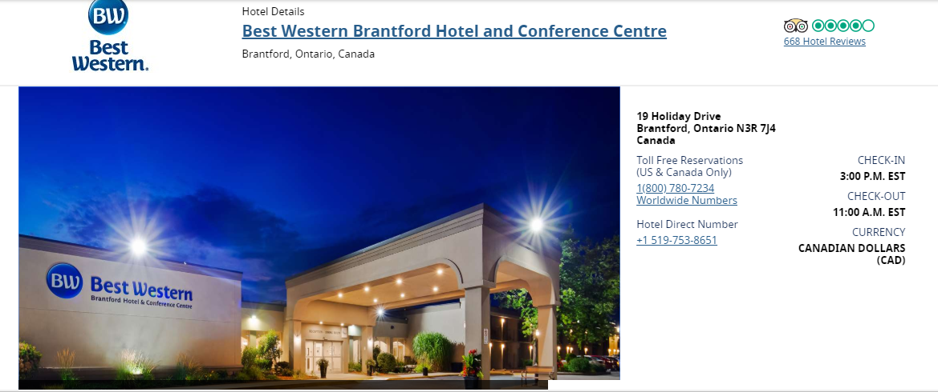

Group name: Phoenix Invitational
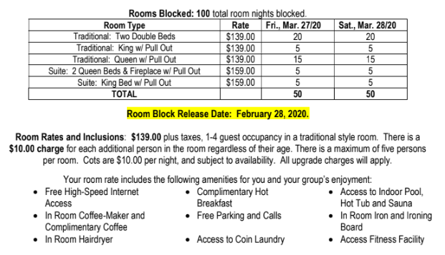

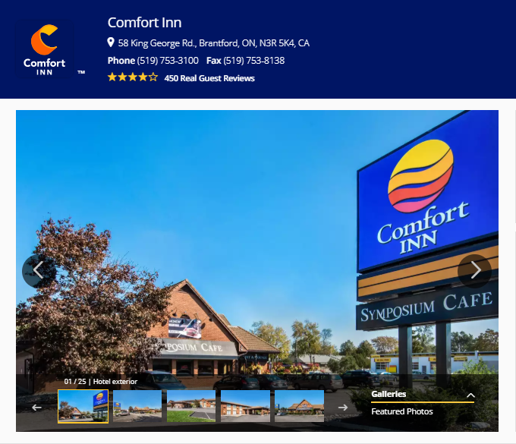

Group name: Phoenix Invitational

Room Type:
- 2 double beds $104.99/ night

Block of rooms will be released after February 27th, 2020

